|  |  |
| --- | --- |
| cid:image004.png@01CF7F10.A4275880 | LOGO4 |
| Best Buy Canada Mobile | |
| |  | | --- | | **Serialized Item Feature Document** |   **Document Version: 1.3**  **Revision Date: April 1, 2015** | |
| **Prepared By: Amy Byers** | |
|  | |

**Table of Contents**

*1.**Feature Overview* 3

1.1 Feature Description 3

1.2 Assumptions 3

1.3 Parameters and System Settings 3

1.4 Interfaces 3

*2.**USE CASE: Serialized Item* 4

2.1 Feature Flow 4

2.2 Precondition 4

2.3 Main Flow 4

2.4 Alternate Flows 5

2.5 Post Condition 5

2.6 Special Requirements 5

*3.**Supplemental Specifications* 6

3.1 Electronic Journal 6

3.2 Manager Override 6

3.3 POSLog 6

3.4 Printed Receipts 6

3.5 Suspend Feature 6

*4.**Screen Layouts* 7

4.1 Serial Number 7

*5.**Business Sign Off* 8

*6.**Revision History* 8

*7.**Appendix A: Glossary* 8

# *Feature Overview*

## Feature Description

The Serialized Item Feature Document describes the functionality where an item requires a serial number to be captured in order to complete the selling of the item.

## Assumptions

1. All text displayed by the system is configurable by brand to support multi-language.  Text is defined from an external source or defined within the system.

## Parameters and System Settings

|  |  |  |
| --- | --- | --- |
| **Parameter Mnemonic** | **Description** | **Valid Values** |
| Serialized Item Attribute | Determines if the item requires serial number to be captured prior to selling the item. | * On * Off |
| Duplicate Serial Number Allowed | Determines if duplicate serial numbers are allowed in the transaction. The parameter is defined at the transaction level and is not on the type of serial number to apply. | * On * Off |
| Number of Failed Retries on Serial Number | Determines the number of failed serial number entries before the system accepts the serial number. For example if the value is 3, then after the 3rd failed attempt the system accepts the last entry as a valid serial number and continues as if the serial number is valid. | * Numeric Value |
| Maximum Failed Serial Number Retry Manager Override Access Point | Determines if manager override is required when the failed serial number retry maximum limit has been met. | * On * Off |
| Skip Serial Number Validation Flag | Determines if IBH allows serial number validation to be skipped. | * On * Off |

## Interfaces

|  |  |
| --- | --- |
| **Interface** | **Description** |
| None |  |

# *USE CASE: Serialized Item*

## Feature Flow



## Precondition

* The operator has chosen to add an item to the transaction that requires a serial number.

## Main Flow

1. The system prompts the operator to enter a serial number.
2. The operator enters a serial number and accepts the entry.
3. If the Skip Serial Number Validation flag is set for the IBH, use case ends and system returns to calling use case.
4. The system determines if the serial number already exists in the transaction.
5. The system evaluates the Duplicate Serial Numbers allowed parameter.
6. If duplicate serial numbers are not allowed, the system displays a message; the operator acknowledges the message and the system restarts the Sale use case and the item is not added to the transaction.
7. The system determines if a Check Digit computation is required.
8. If a Check Digit computation is required, the Validate Digit Check alternate flow is executed.
9. If the serial number is invalid, the Invalid Serial Number alternate flow is executed.
10. The use case ends and the system returns to the calling use case with a serial number.

## Alternate Flows

### Invalid Serial Number

1. The system checks the number of failed attempts of serial number for this item.
2. If the number of failed attempts is less than the limit, the system displays a message, the operator acknowledges the message and the system restarts the Main Flow.
3. If the number of failed attempts has reached the limit, the system evaluates serial number retry manager override access point.
4. If the serial number retry manager override access point is disabled, the system returns to the Main Flow where the use case ends and the system returns to the calling use case with a serial number.
5. If the serial number retry manager override access point is enabled, the system executes the Manager Override use case.
6. The system receives a manager override decision.
7. If the manager override is approved or queued, the system returns to the Main Flow where the use case ends and the system returns to the calling use case with a serial number.
8. If the manager override is denied, the use case ends and the system returns to the calling use case **without** a serial number.

## Post Condition

* A serial number is linked to an item.

## Special Requirements

1. A serialized item attribute determines if capturing a serial number is required.
2. The system validates serial numbers based on minimum and maximum length (UI) and through the use of regular expressions.
3. For imported items, the serialized item flow is not executed.
4. If a serialized item is selected to override quantity, System will not prompt for serial number again.

### Special Offline Requirements

TBD

### Data Input/Output

|  |  |  |
| --- | --- | --- |
| **Data Element** | **Description** | **Destination** |
| Serial Number | Entered serial number | * E-Journal * POSLog * Receipt |
| Item Number | The item that the serial number is associated to | * E-Journal * POSLog * Receipt |

# *Supplemental Specifications*

## Electronic Journal

Electronic journal mockups for this feature are documented in the Electronic Journal document.

## Manager Override

The Manager Override feature is executed if the serial number failed retry limit has been met and requires manager override before the system continues with accepting the serial number entry.

## POSLog

POSLog mockups for this feature are documented in the POSLog document.

## Printed Receipts

Printed receipt mockups, where applicable, are documented in the Receipt Generation document.

## Suspend Feature

The Suspend Use Case is updated to reflect that the data captured prior to suspending a transaction is available when the transaction is resumed.

# *Screen Layouts*

## Serial Number

This pop over is displayed when an item is flagged as requiring a serial number is added to a transaction. The screen prompts the operator to capture the serial number associated to the item. Serial numbers can be scanned or manually entered. Scanning or swiping is an implied enter.

### Mockup

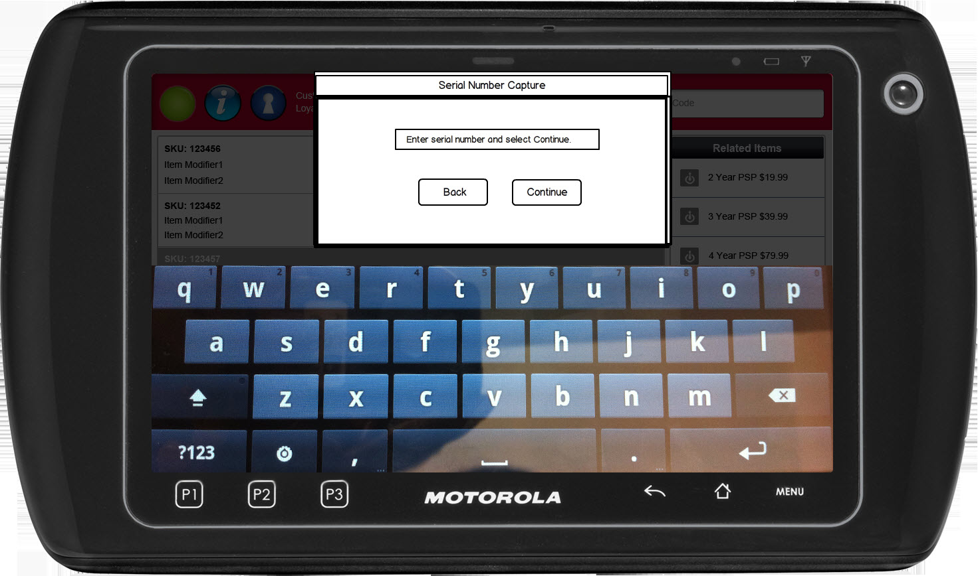

Figure 1: Serial Number

### Instruction Text Enhancements

|  |
| --- |
| **Instructions** |
| None |

### Navigation/Menu Key Enhancements

|  |  |  |  |
| --- | --- | --- | --- |
| **Label** | **State** | **Next Screen** | **Notes** |
| Back | Enabled | Sale use case |  |
| Continue | Enabled | * Valid Serial Number: Sale use case * Invalid Serial Number: Serial Number |  |

### Data/Input Field Enhancements

|  |  |  |  |  |  |  |
| --- | --- | --- | --- | --- | --- | --- |
| **Label** | **Editable** | **Req’d?** | **Data Type** | **Min**  **Length** | **Max**  **Length** | **Notes** |
| Enter serial number and Select Continue | Yes | No | Alphanumeric | 0 | 35 | A null value is acceptable. The Check Digit logic when required, will check if a null value is acceptable. |

### Reason Code Enhancements

|  |  |  |
| --- | --- | --- |
| **Reason Code** | **Valid Values** | **Default Value** |
| None |  |  |

### Invalid Data Notice

|  |  |
| --- | --- |
| **Description** | The Invalid Data Notice informs the operator that the data entered in the required fields is invalid (e.g. incorrect format, missing). The <ARG> described in the Message is replaced with the name of the data field that contains the invalid data. If there are multiple data fields with invalid data, the system only displays the name of the first data field with invalid data. Upon acknowledging the message, the system returns to the previous screen. |
| **Message** | The following field has invalid data: <ARG>. Please correct the invalid data. |
| **Key prompt** | OK |
| **Notes** | This is a generic message to be reused when required data is incorrect or missing. |

### Reason Code Enhancements

|  |  |  |
| --- | --- | --- |
| **Reason Code** | **Valid Values** | **Default Value** |
| None |  |  |

# *Business Sign Off*

|  |  |  |
| --- | --- | --- |
| **Name** | **Organization** | **Date** |
|  |  |  |

# *Revision History*

|  |  |  |  |
| --- | --- | --- | --- |
| **Reviser** | **Revision** | **Date** | **Version** |
| Amy Lackas | Initial document created. | 01/11/2013 | 1.0 |
| Amy Lackas | Updates after internal review | 01/20/2013 | 1.1 |
| Amy Byers | Added that serialized items with quantity overridden do not prompt for serial numbers again. | 3/20/2015 | 1.2 |
| Amy Byers | Added IBH skip validation feature | 4/1/2015 | 1.3 |

# *Appendix A: Glossary*

|  |  |
| --- | --- |
| **Term** | **Definition** |
| IBH | International Business Hierarchy |